

**PES UNIVERSITY**

**(Established under Karnataka Act No. 16 of 2013)**

**100-ft Ring Road, Bengaluru – 560 085, Karnataka, India**

***Report on***

**‘ROBOTIC ARM BCI’**

***Submitted by***

**HARSHITA R VASTRAD (PES1201701717)**

**V SAISRI (PES1201701763)**

**SHREYA V DEEXIT (PES1201701648)**

**August - December 2020**

**under the guidance of**

***Internal Guide***

**Dr. Niranjana Krupa**

**Professor**

**And**

**Prof. Shweta G**

**Assistant Professor**

**Department of ECE**

**PES University**

**Bengaluru -560085**

**FACULTY OF ENGINEERING**

**DEPARTMENT OF ELECTRONICS AND COMMUNICATION ENGG**

**PROGRAM B.TECH**



**CERTIFICATE**

*This is to certify that the Report entitled*

**‘Robotic Arm BCI’**

*is a bonafide work carried out by*

**HARSHITA R VASTRAD (PES1201701717)**

**V SAISRI (PES1201701763)**

**SHREYA V DEEXIT (PES1201701648)**

In partial fulfillment for the completion of 7th semester course work in the Program of Study B.Tech in Electronics and Communication Engineering, under rules and regulations of PES University, Bengaluru during the period Aug – Dec. 2020. It is certified that all corrections/suggestions indicated for internal assessment have been incorporated in the report. The report has been approved as it satisfies the 7th semester academic requirements in respect of Capstone project work.

*Signature with date & Seal Signature with date & Seal*

*(Dr/ Prof …..) Dr. Anuradha M*

*Internal Guide Chairperson*

*Signature with date & Seal*

*Dr. B. K. Keshavan*

*Dean - Faculty of Engg. &Technology*

Name and signature of the examiners:

1.

2.

**DECLARATION**

We, Shreya V Deexit, V Saisri, Harshita R Vastrad**,** hereby declare that the report entitled, ‘***Robotic Arm BCI’,*** is an original work done by us under the guidance of **Dr.Niranjana Krupa**, Professor, ECE department and **Prof.Shweta G**, Assistant Professor, ECE Department and is being submitted in partial fulfillment of the requirements for completion of 7th Semester course work in the Program of Study, B.Tech in Electronics and Communication Engineering.

**PLACE : BANGALORE**

**DATE : 08/01/2021**

**NAME AND SIGNATURE OF THE CANDIDATES**

1.**Harshita R Vastrad -**

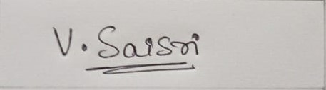

2.**V Saisri -**



3. **Shreya V Deexit -**

**ABSTRACT**

A modern technology which is currently revolutionizing the field of signal processing is Brain Computer Interfaces (BCI). In this project the main focus is on EEG signal processing and classification for motor imagery using machine learning.It also focuses on accurate classification of the user’s Action/Cognitive thoughts, where successful decoding of EEG signals can provide a higher degree of freedom (DOF) control in Brain Robot Interface (BRI) applications. The EEG signals from the user’s scalp are recorded through non-invasive electrodes and pre-processed to produce noise free EEG signals. To extract features from the EEG signal time-frequency analysis techniques are used. In this project an Artificial Neural Network (ANN) machine learning algorithm is used as a classifier to extract the EEG signal features for effective output classification. This work gives a performance analysis on the accuracy of the system for the proposed combination of ANN algorithm and Time-Frequency analysis for the EEG feature extraction and classifier respectively

**Keywords:** electroencephalography (EEG); brain-computer interface (BCI); brain-robot interface (BRI); motor-imagery (MI)

**Acknowledgement**

**With immense pleasure, presenting our project ‘BCI Robotic Arm’ report as a part of our curriculum in ‘B.Tech in Electronics and Communication Engineering’. We wish to all people who gave us endless support throughout.**

**We express our profound gratitude to our guide Dr. Niranjana Krupa and Prof.Shweta G for giving us guidance and encouragement throughout the course of our project.**

**Shreya V Deexit**

**V Saisri**

**Harshita R Vastrad**

**TABLE OF CONTENTS**

**1. Introduction**  1

**2. Literature review**  2

2.1. Brain Controlled Interface…………………………………….......2

2.2.Electroencephalogram(EEG)…………………………………….......2

2.3. Motor Imagery……………………………………………………3

2.4. Wavelet Packet Decomposition…………………………...............3

2.5. Related Work..…………………………………………………….4

**3. Methodology**  5

3.1. Extracting the data………………………………………...............5

3.2. Pre-processing…………………………………………………….6

3.3. Wavelet packet decomposition…………………………………....7

3.4. Building the model………………………………………………..9

3.5.10-fold cross-validation…………………………………………..11

**4. Block Diagram**  12

**5. Result**  13

**6. Analysis of result**  13

**7. Conclusion** 14

**8. Future scope**  14

**9. References** 15

**List of tables and figures**

Figure 1: Brain Robot Interface Schematic…………………………………………………....1

Figure 2: Timing scheme of each trial paradigm……………………………………………..5

Figure 3: Frequency spectrum after bandpass filtering………………………………………6

Figure 4. DWT signal decomposition………………………………………………………..8

Figure 5. EEG Signal DWT decomposition………………………………………………….8

Figure 6: Summary of the model……………………………………………………………..9

Figure 7: Illustration of early stopping……………………………………………………....10

Figure 8: Train test split……………………………………………………………………...11

Figure 9: Process step flow diagram…………………………………………………………12

Table 1: Decomposition level for frequency bands…………………………………………...7

Table 2: Accuracy of Classification………………………………………………………….13

**1. INTRODUCTION**

The robotic technology is increasing day by day.The advancements in robotics over the past decade have demonstrated that robotic devices can manipulate,locomote, and interact with people and their environment in unique ways.Robots are also starting to help disabled people.

Paralysis is one of the major neural disorders that causes loss of motion of one or more muscles of the body. The disabled people suffering from neuromuscular injuries can be benefited from the robots.The voice controlled robots have been developed by researchers to help the disabled.There are also many ways which make use of robots where they focus on the interaction between the human and robot without the involvement of a human's hand.The Brain Signals of such patients can be used to help them communicate to others and also to perform various tasks by providing necessary infrastructure and training. The BCI system processes the electrical activity of the brain and generates the commands.Hence external devices can be controlled using these commands.

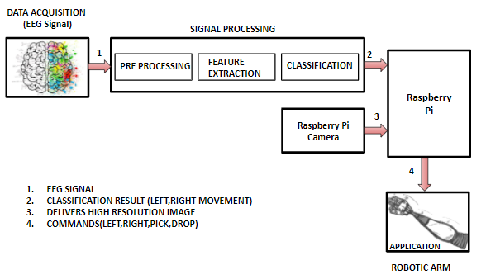**Figure 1: Brain Robot Interface Schematic**

**2. LITERATURE REVIEW**

2.1. Brain Controlled Interface

Brain Computer Interfaces measure brain activity,It does it by using electrodes to detect electric signals in the brain which are sent to a computer. The computer then extracts features from that activity, and convert those features into outputs that replace, restore, enhance, supplement, or improve human functions

2.2. Electroencephalogram (EEG)

The electroencephalogram is a recording of the electrical activity of the brain from the scalp. The recorded waveforms reflect the cortical electrical activity.

Signal intensity- EEG signal is quite small, usually in microvolts (mV).

Signal frequency- the main frequencies of the human EEG waves are:

1. Delta- are slowest waves. It is normal as the dominant rhythm in infants up to one year and in stages 3 and 4 of sleep.
2. Theta- is classified as "slow" activity. It is normal in children up to 13 years and in sleep but abnormal in awake adults.
3. Alpha- is usually seen in the posterior parts of the head on each side, it is higher in amplitude on the dominant side. It appears when closing the eyes and relaxing, and disappears when opening the eyes or alerting by any mechanism like thinking, calculating.
4. Beta- is classified as "fast" activity.It is seen on both sides in symmetrical distribution and is evident frontally. In general it is regarded as a normal rhythm. It is the dominant rhythm in people who have their eyes open or are alert or anxious.

2.3. Motor Imagery

Motor imagery based brain-computer interface (BCI) is one of the standard concepts of BCI, in MI the user can generate induced activity from the motor cortex of the brain by imagining motor movements without any hand movement or external stimulus.

Motor imagery signals recorded via electroencephalography is the most convenient basis for designing brain-computer interfaces. As MI based BCI provides a high degree of freedom, it helps motor disabled people to communicate with the device by performing sequences of MI tasks.

2.4. Wavelet Packet Decomposition

Discrete Wavelet Transform is a time-frequency analysis of signals that inherits multi-resolution nature. DWT samples the signal into discrete wavelets, the key advantage of DWT over Fourier Transform is that it has temporal resolution along with frequency resolution information, Hence it is called a time-frequency analysis.

Data pre-processing by wavelet packet analysis methods usually gives a relatively satisfactory ANN modeling result. Usually the decomposition level chosen is in accordance to series length.Theoretically, the maximum decomposition level (M) can be calculated as:

M = log2 (N), where N is the series length.

The higher the number of vanishing moments, the smoother the wavelet (longer the wavelet filter). The length of the wavelet filter is two times that number. The significance of this is that if the signal is exhibiting behavior on an interval consistent with a polynomial of degree at most N and the wavelet has N vanishing moments, the wavelet coefficients will be zero in that interval. The wavelet having N vanishing moments is orthogonal to polynomials of degree at most N. So a “db1” will return wavelet coefficients of zero in the interval if the signal is a polynomial of degree at most 1 in that interval.

2.5. Related Work

The primary reference paper that was used to implement ‘Robotic Arm BCI’ was reference paper[2].From this paper we understood how to use a bandpass filter using Hamming-windowed zero phase finite impulse response (FIR) and form a hybrid deep learning model using the CNN and the BiLSTM.After spatial filtering, twenty EEG channels near the primary/supplementary motor cortices were selected. The multidirectional CNN-BiLSTM network (MDCBN)-based deep learning framework considering 3D multi-direction was used.

ICA(Independent component analysis) algorithm to remove the contaminated channels was tried using the reference paper[1].From this paper different concepts like zero-phase second-order Butterworth bandpass filter with a cutoff frequency from 4 to 40 Hz,HF-CNN model of classification was also learnt.They have trained the HF-CNN according to each subject because of the EEG uncertainty characteristics.

Different classification techniques were studied from reference [5].In this paper they have used three different classification algorithms like SVM, KNN and LDA.By comparing all classifiers LDA gave better accuracy of about 87.5%.The robotic arm interfacing was done using Matlab and Arduino board. The Bluetooth module controls the robotic arm wirelessly.

The concept of spatial filtering using common spatial patterns was known using the paper[3].This paper even gave a brief description of Mutual information(MI) algorithm for feature selection and naive bayesian classifier for classification.

Reference paper[4] gave a comparison of different classifiers for BCI.It gave an idea about different classification techniques that are currently being used in the field of BCI. Some of the techniques are Linear Discriminant Analysis (LDA), Support Vector Machine (SVM), and k-Nearest Neighbor (kNN), LSTM, Bi-LSTM, CNN-LSTM, and Bi-LSTM CNN.This helped us to understand the scope of applications and the different models.

**3. METHODOLOGY**

3.1. Extracting the data

3.1.1. The Dataset

We have used Dataset BCI Competition IV 2a that was presented by Graz University. This dataset contains the EEG data from 9 healthy subjects performing four classes of motor imagery namely movement of the right hand, left hand, feet, and tongue. The dataset is recorded in two sessions on different days for each subject. Dataset one of sessions used for training and the other for evaluation. Each of the training and evaluation sessions consists of six runs separated using short breaks and each run contains 48 trials (12 trials for each class).Each session consisted of 288 trials (72 trials per class). The signals were recorded from the 22 EEG channels in accordance with the international 10-20 system and 3 monopolar EOG channels. They were sampled with 250 Hz sampling rate and band-pass filtered in the frequency range of 0.5-100 Hz. An additional 50 Hz notch filter has been utilized to suppress power line noise. The EOG channels are used for the subsequent application of artifact removal methods and should not be used for classification.Files are in .gdf format.

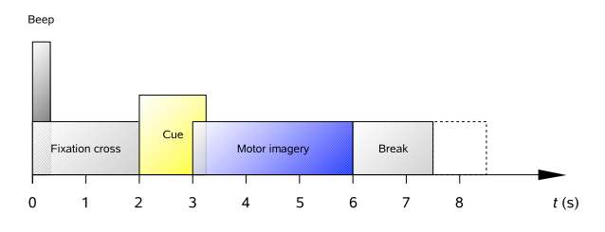**Figure 2: Timing scheme of each trial paradigm**

**3.2. Pre-processing**

**3.2.1. Event Extraction**

Voluntary and imaginary movements were collected based on the events and these events were extracted and classified into 11 types.Out of 11,only 4 were needful and these essential events are as follows:

i)Cue onset left (class 1)

ii)Cue onset right (class 2)

iii)Cue onset foot (class 3)

iv) Cue onset tongue (class 4)

**3.2.2. Bandpass Filtering**

After extracting the required events we use a one-pass, zero-phase, non-causal bandpass filter with hamming window where frequencies in a frequency band are passed.The frequency band of 7Hz to 35Hz range is selected.The region used in the model is shown in Figure 3.

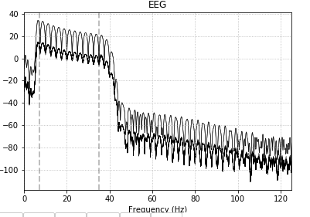

**Figure 3: Frequency spectrum after bandpass filtering**

**3.2.3. Channel Selection**

The 25 electrodes are used for extracting the EEG signals out of which 22 are EEG channels and the other 3 are EOG channels.The EOG channels are considered as bad channels.The presence of EOG channels in the process of classification will affect the classification rate.Hence for a better accuracy these bad channels are removed thereby using 22 channels for classification.

**3.3. Wavelet packet decomposition**

To analyze the EEG signal we split the EEG signal into sub-bands such as Delta(0.5 to 4 Hz), Theta(4 to 8 Hz), Alpha( 8 to 16 Hz), Beta( 16 to 32 Hz),Gamma( >32 Hz) .

A 2 level Discrete Wavelet Transform (DWT) with a mother wavelet of ‘db4’ is applied on the filtered EEG signals which produced 3 sets of detailed coefficients D3, D4,D5 from the decomposed EEG signal.

| Decomposition Level | Frequency Bandwidth(Hz) | Frequency Bands |
| --- | --- | --- |
| D1 | 64-128 | Noise |
| D2 | 32-64 | Noise(Gamma) |
| D3 | 16-32 | Beta |
| D4 | 8-16 | Alpha |
| D5 | 4-8 | Theta |
| A5 | 0.5-4 | Delta |

**Table 1: Decomposition level for frequency bands**

Single level DWT of a signal is calculated by passing the signal through highpass and lowpass filters which produces detailed coefficients and approximated coefficients respectively, in accordance to Nyquist’s rule half the samples can be discarded by sub-sampling with 2. For N multi-level DWT, the approximate coefficients from each level is decomposed further by repeatedly passing through highpass and lowpass filters till nth level detailed and approximated coefficients are obtained as shown in figure 2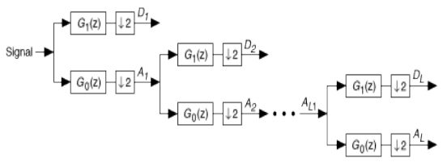

**Figure 4. DWT signal decomposition**

The decomposed EEG signal in the frequency resolution can be seen in figure 3

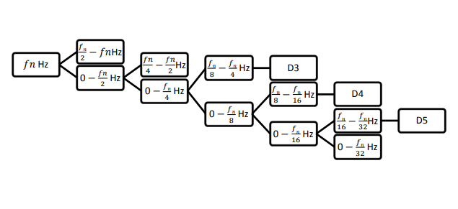**Figure 5. EEG signal DWT decomposition**

**3.4. Building the model**

In order to classify the extracted features from the EEG signals we use Artificial neural networks architecture to classify the four classes. The model is composed of 4 layers.The output matrix for neural network is of 4x288, four motor imagery tasks for 288 data samples.The input layer consists of 124 neurons. A dropout of 0.5 is used.The activation function used in this layer is Relu.

There are two hidden layers in the model each consisting of 124 neurons,activation function as Relu and a dropout of 0.5.The L2 regularisation was used which works well

The output layer consists of 4 neurons since there are 4 classes to classify.Each neuron represents each class.The activation function used in the output layer is softmax.The optimizer chosen for this model is adam and the loss as categorical cross entropy since its a multiclass problem.The below figure shows the summary of the model which we have used.

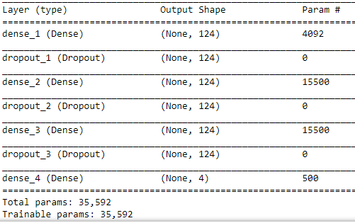

**Figure 6: Summary of the model**

*Early stopping*

The most common problem with training neural networks is in the choice of the [number of training epochs](https://machinelearningmastery.com/difference-between-a-batch-and-an-epoch/).Too many epochs can lead to overfitting of the training dataset which would lead to the decrease in accuracy of the model, whereas choosing very few number of epochs may result in an underfit model.Early stopping is a method that allows to specify an arbitrary large number of training epochs and stop training once the model performance stops improving on a hold out validation dataset.

Figure 4 represents the plot of training loss and validation loss against the number of epochs. It can be depicted from the graph that when the validation loss tries to increase with respect to the training loss,the training is stopped.

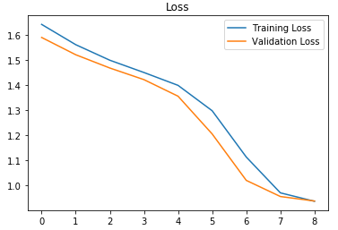

**Figure 7: Illustration of early stopping**

**3.5. 10-fold cross-validation**

In 10-fold cross-validation, the original sample is randomly partitioned into 10 equal size subsamples. Of the 10 subsamples, a single subsample is retained as the validation data for testing the model, and the remaining 9 subsamples are used as training data. The cross-validation process is then repeated 10 times (the folds), with each of the 10 subsamples used exactly once as the validation data.

The 10 results from the folds can then be averaged to produce a single estimation. The advantage of this method is that all observations are used for both training and testing, and each observation is used for testing exactly once.

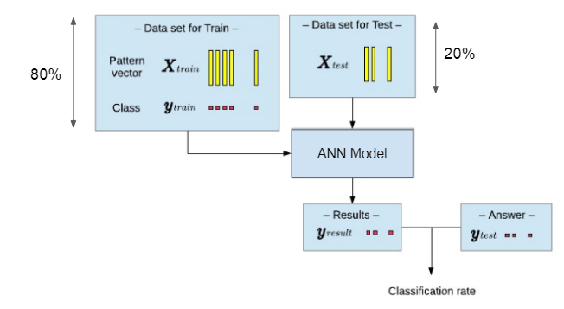

**Figure 8: Train test split**

**4. BLOCK DIAGRAM**

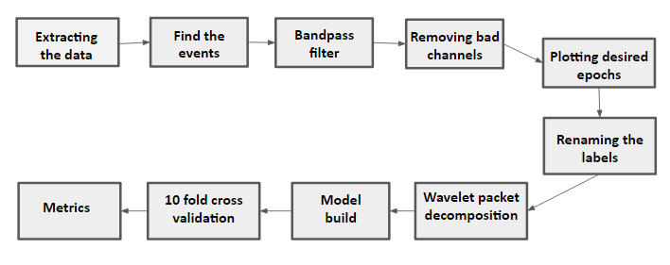

**Figure 9: Process step flow diagram**

**5. RESULT**

The output obtained is the overall accuracy of all the four classes(class 1-left,class 2-right,class 3-down,class 4-up) combined.The overall and average accuracy percentage of the neural network for the subjects over different statistical features is calculated by means of 10 Fold Cross Validation method. Table 1 presents each fold accuracy,kappa,precision, recall and average classification accuracy for different statistical features extracted from 22 channels.

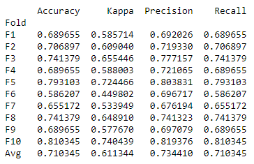

**Table 2: Accuracy of Classification**

**6. ANALYSIS OF RESULT**

Initially a single hidden layer model was implemented.The average accuracy obtained was 68%.We tried to fine tune this model by varying different parameters like changing the optimizer used,the number of hidden layers,applying regularization techniques,changing the dropout value. The best accuracy was obtained for a 4 layer model containing two hidden layers with a drop out of 0.5,optimizer as adam and using L2 regularization technique.We noticed that accuracy was improved by adding early stopping to our training phase.

**7. CONCLUSION**

Varying different parameters of the model like changing the optimizer, changing the dropout value, number of layers, also adding early stopping to reduce overfitting and L2 regularisation . By comparing accuracies for all the variations we can say that on using Adam optimizer ,drop out of 0.5 , 2 hidden Layers along with early stopping and L2 regularisation we achieved the best average accuracy of 71.03% .

**8. FUTURE SCOPE**

There still exists future scope towards optimization in the network architecture and feature selection, here we have used a fixed architecture for analysis. Considering optimal selection of correct bandwidth of the frequency range of EEG signal that should be filtered out could be studied and analysed. Further along with optimization of the neural network architecture and feature selection, the study can be carried out in online training of the neural network.

**9. REFERENCES**

**[1]** JI-HOON JEONG1, BYEONG-HOO LEE1, DAE-HYEOK LEE1, YONG-DEOK YUN1, AND SEONG-WHAN LEE2,**”EEG Classification of Forearm Movement Imagery Using A Hierarchical Flow Convolutional Neural Network”**, (FELLOW, IEEE)

**[2]** Ji-Hoon Jeong , Kyung-Hwan Shim , Dong-Joo Kim , and Seong-Whan Lee, **“Brain-Controlled Robotic Arm System Based on Multi-Directional CNN-BiLSTM Network Using EEG Signals”**,[IEEE Transactions on Neural Systems and Rehabilitation Engineering](https://ieeexplore.ieee.org/xpl/RecentIssue.jsp?punumber=7333) (Volume: 28 , [Issue: 5](https://ieeexplore.ieee.org/xpl/tocresult.jsp?isnumber=9090036), May 2020 )

**[3]** [Maryam Mohammadi](https://ieeexplore.ieee.org/author/37086353197); [Mohammad Reza Mosavi](https://ieeexplore.ieee.org/author/37299368300)**,”Improving the efficiency of an EEG-based brain computer interface using Filter Bank Common Spatial Pattern”,**[2017 IEEE 4th International Conference on Knowledge-Based Engineering and Innovation (KBEI)](https://ieeexplore.ieee.org/xpl/conhome/8316804/proceeding)

**[4]** Aldwin Jomar F. Castro , Justine Nicole P. Cruzit **“Development of a Deep Learning-Based Brain-Computer Interface for Visual Imagery Recognition”,** [2020 16th IEEE International Colloquium on Signal Processing & Its Applications (CSPA)](https://ieeexplore.ieee.org/xpl/conhome/9052211/proceeding)

**[5]** C P Shantala,C R Rashmi,**“Mind controlled wireless robotic arm”**,2017 IEEE International Conference on Computational intelligence and computing research.

**[6]** Rich Caruana, Steve Lawrence, and Lee Giles,“ **Overfitting in Neural Nets: Backpropagation, Conjugate Gradient, and Early Stopping.**”

**[7]** Kristin P. Bennett and Emilio Parrado-Hernandez,”**The Interplay of Optimization and Machine Learning Research**”,Journal of Machine Learning Research 7 (2006)

**[8]** [Types of Optimization Algorithms used in Neural Networks and Ways to Optimize Gradient Descent](https://towardsdatascience.com/types-of-optimization-algorithms-used-in-neural-networks-and-ways-to-optimize-gradient-95ae5d39529f)

**[9]** Diederik P. Kingma, and Jimmy Lei Ba, “**ADAM: A METHOD FOR STOCHASTIC OPTIMIZATION**”,Published as a conference paper at ICLR 2015

**[10]** L1 and L2 Regularization Methods <https://towardsdatascience.com/l1-and-l2-regularization-methods-ce25e7fc831c>